1. Create the java project and deploy on the SonarQube.

Installing of Sonarqube into our windows system.

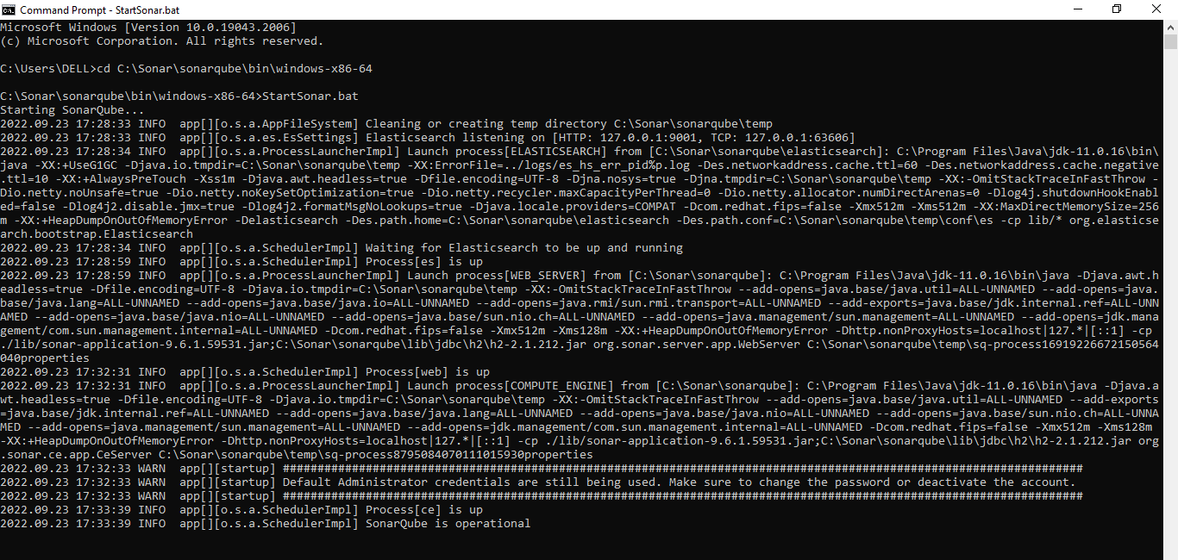

Here we have the SonarQube page after setuping go to chrome type localhost:9000 and give id as well as password and now display the sonarqube page.

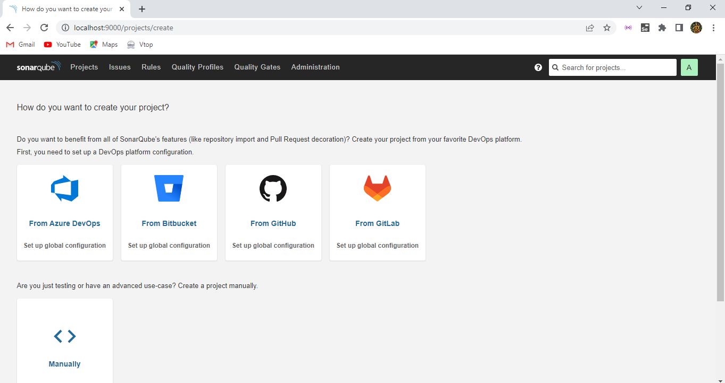

Select the option as manually.

Before set up create the java project on any platform and give the project name here:

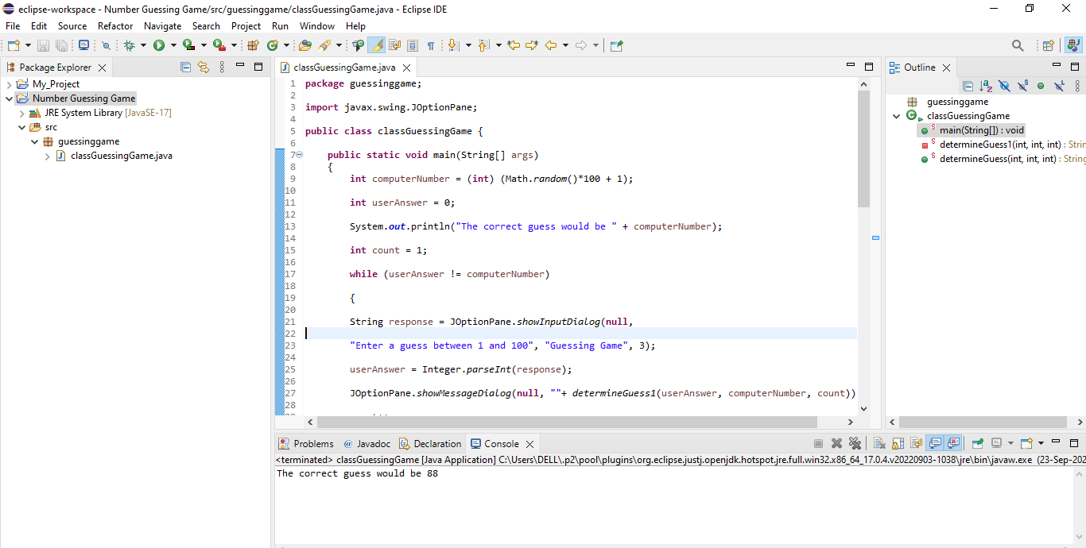

Then after creating give the project name and give setup option.

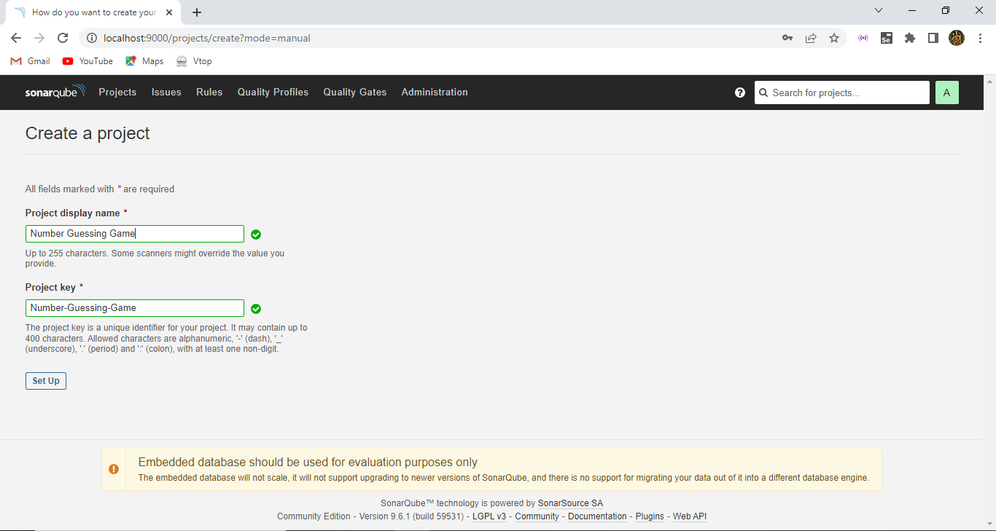

Select the locally option here.

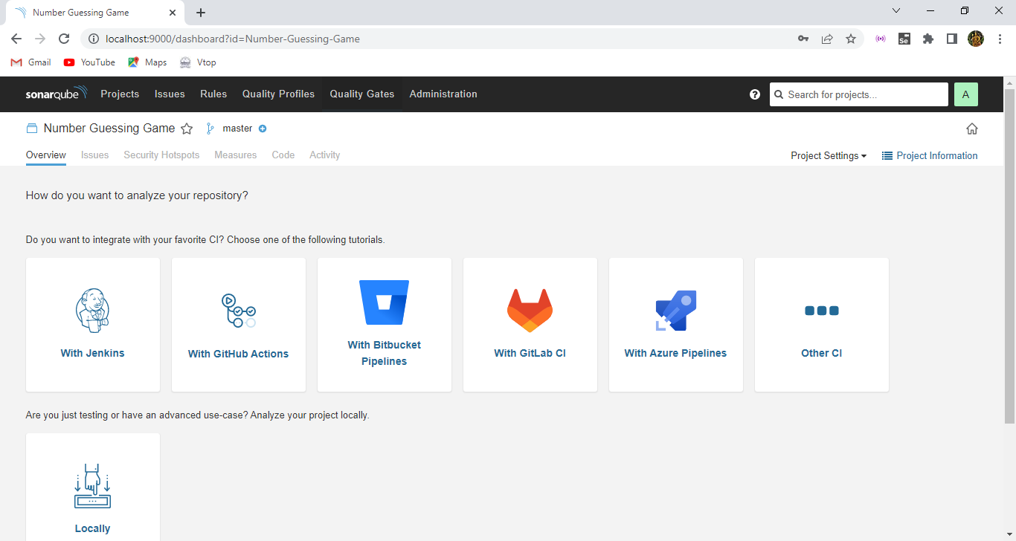

Now it will ask us to enter the token for our project, so default our project name is displayed in the token side and give no expiration and click generate.

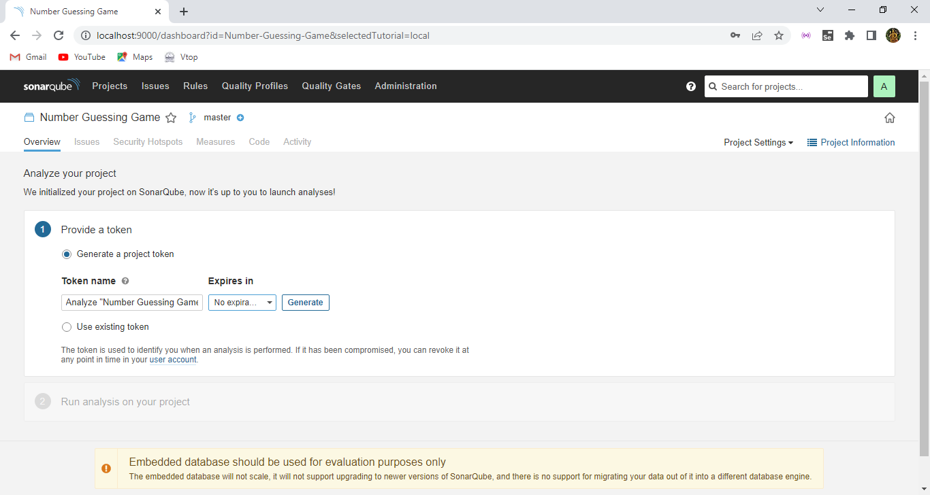

Now we have the token for our project and give continue here.

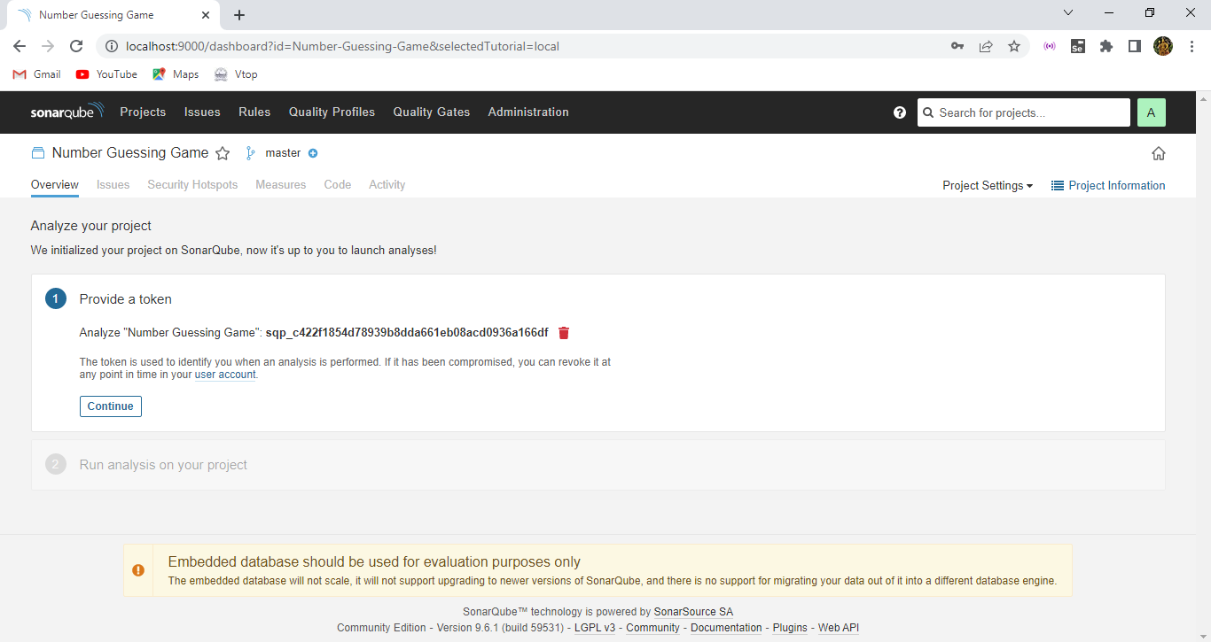

For analyzing the project promote here where we are going to build it and select the option as other , OS as windows.

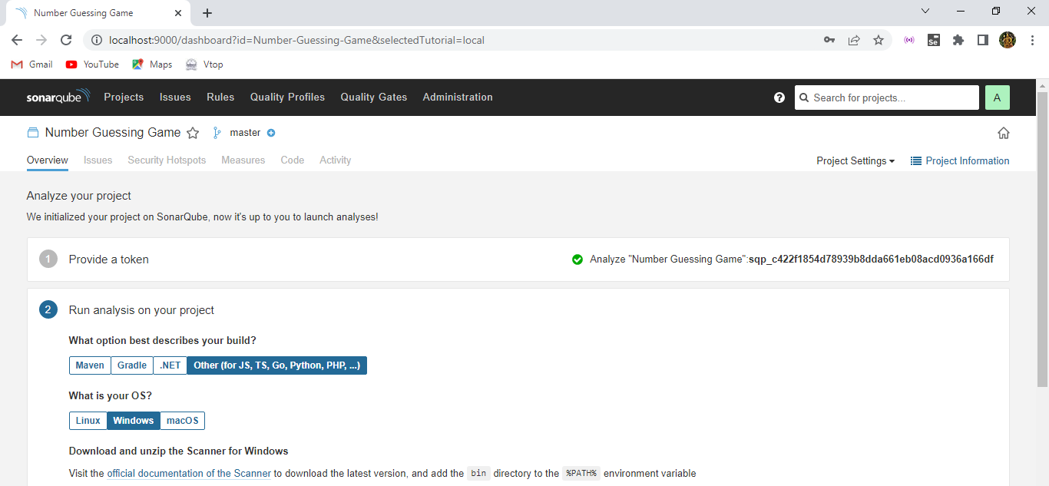

Then after giving the details we get the sonarqube analysis for executing or building our java project.

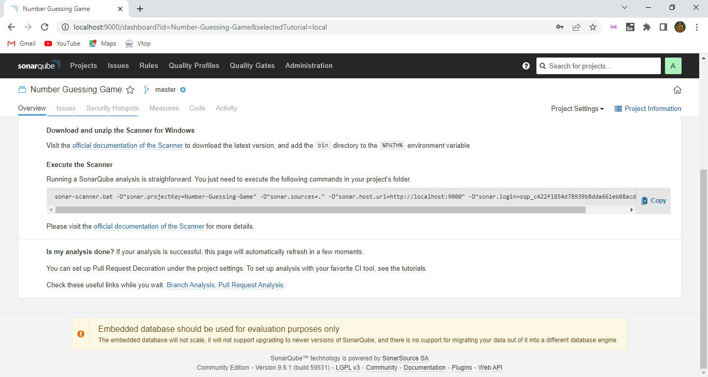

Copy that line of running sonarqube format and then open cmd make the directory as we have created the project in eclipse, so copy the project path and assign the directory in the cmd.

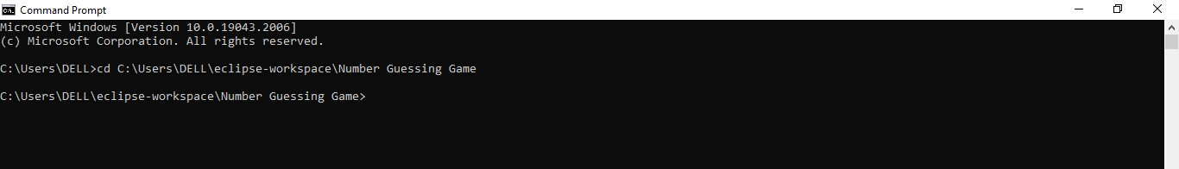

Now copy the sonarqube execution line and attach with the sonar scanner path to it. Because we need to execute or build our project using the sonar scanner of it so with sonar scanner path + our project sonarqube running path then press enter. So the process goes on.

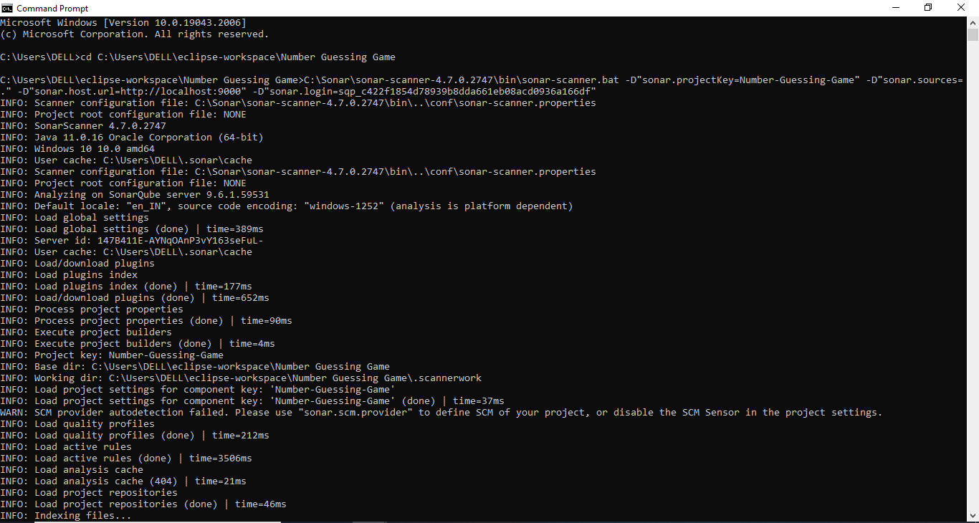

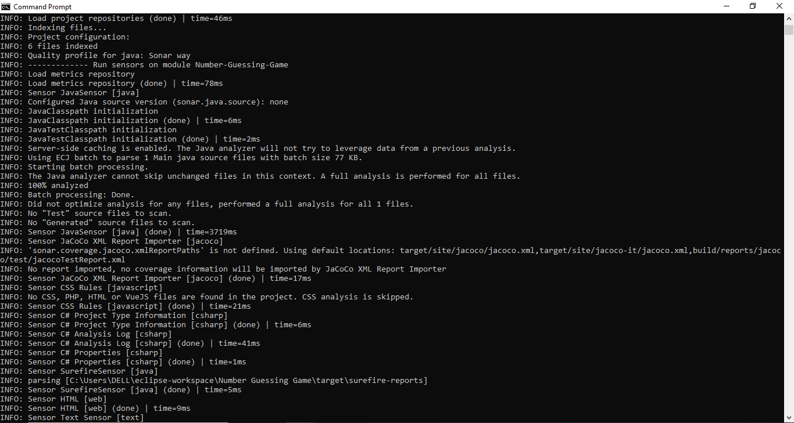

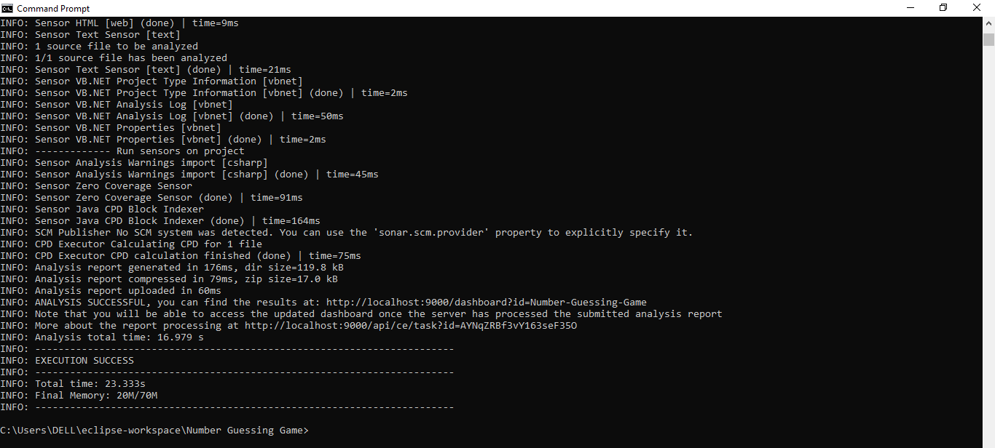

Now we can see the execution success and time and memory happens in it.

Then go to page and reload the output will be displayed.

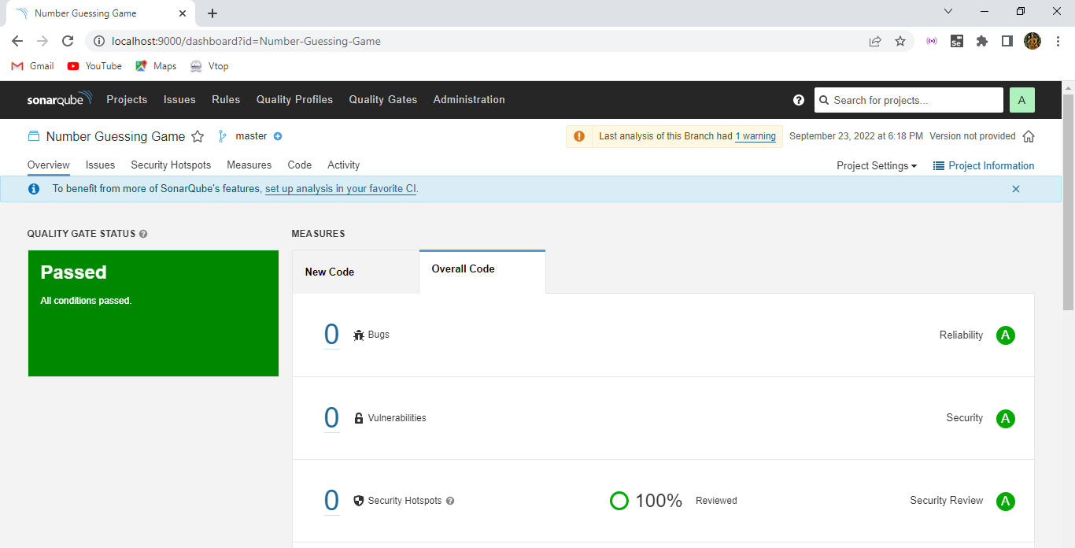

Now this output of the java project is deployed in sonar qube of it. Now after getting output we have some bugs, security cons and we have rectified that and finally our project is clear and successfully deployed in the sonarqube in it.

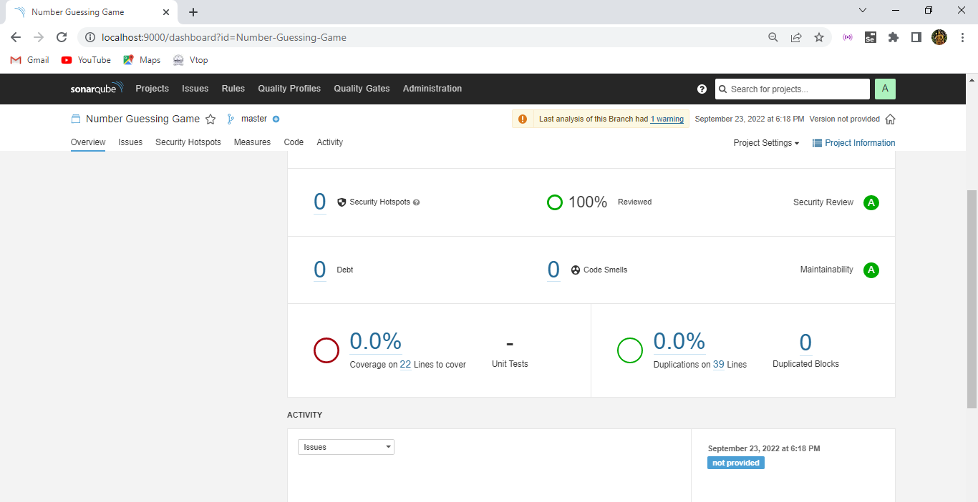

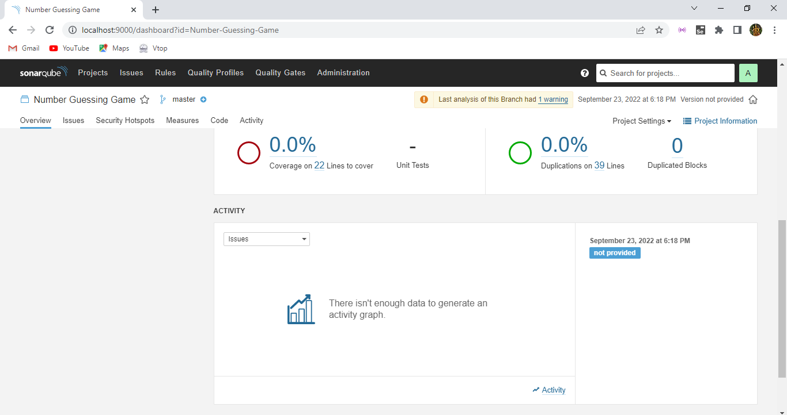

And we can see the output of the sonarqube for our project of it.

Here the code part how many lines of code , bugs , vulnerabilities, code smells, security, coverage, duplications are displayed here.

Now error here hence it is successfully passed everything.

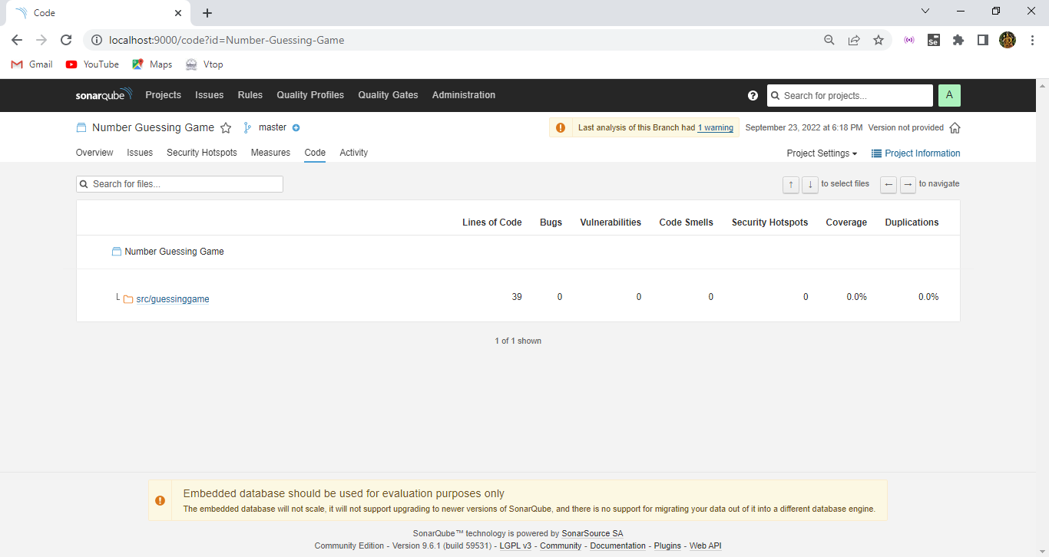

Hence this is the after successful of our project the overview of the sonarqube that we have created and successfully deployed over there.

